React.js Component Creation

Name: Ravulapalli Madhavi

Email:[madhaviravulapalli14@gmail.com](mailto:madhaviravulapalli14@gmail.com) Roll NO: 20NN1A0543

College Name: Vignan’s Nirula Institute of Technology and Science For women University: JNTUK

source code:

CARD COMPONENT:

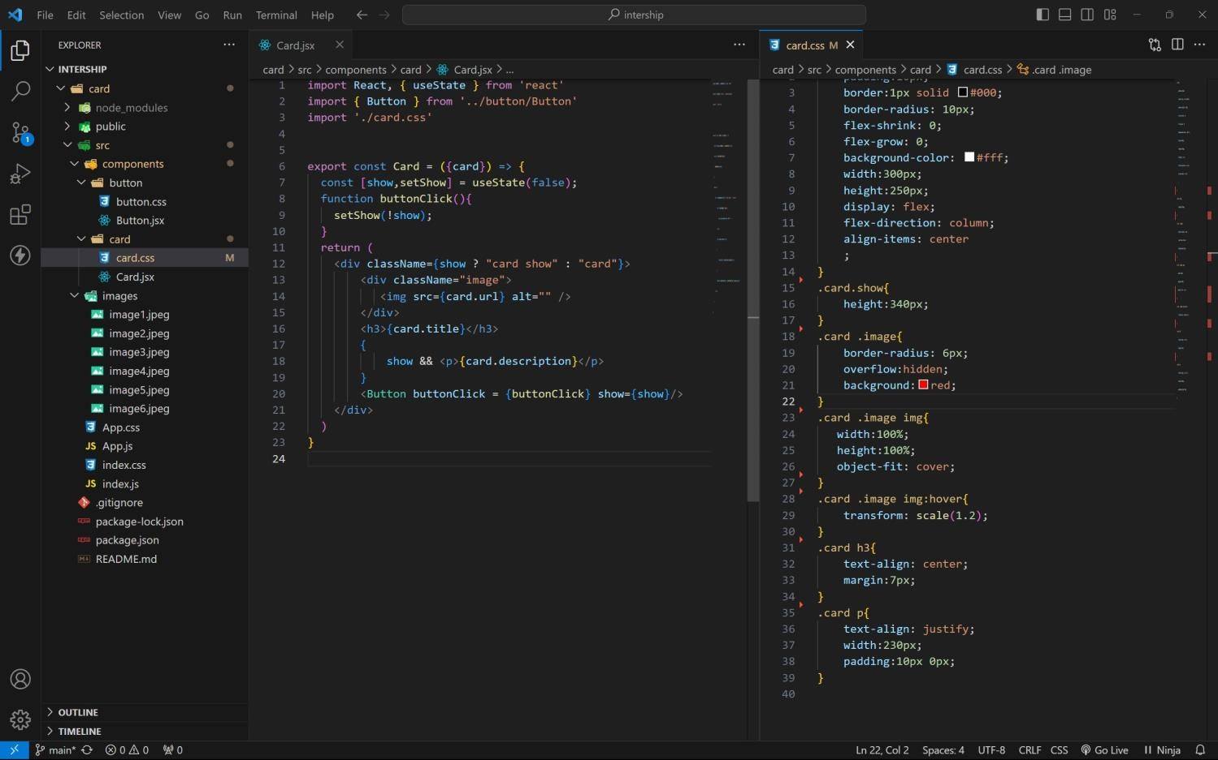

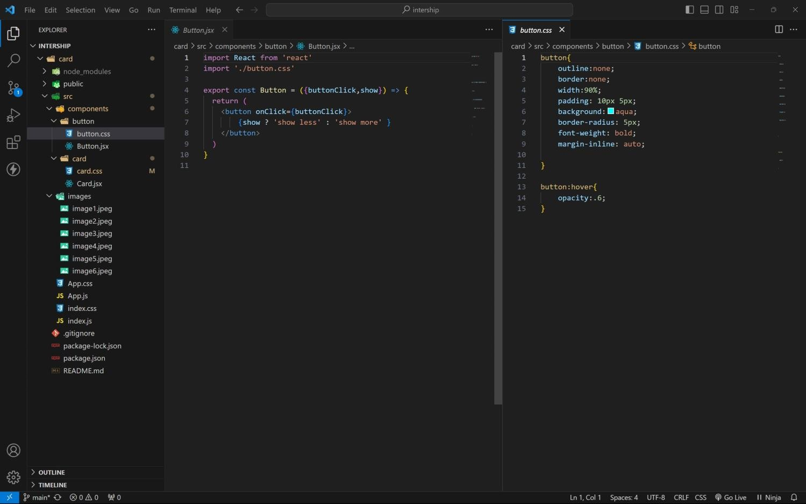BUTTON COMPONENT:

APP COMPONENT:

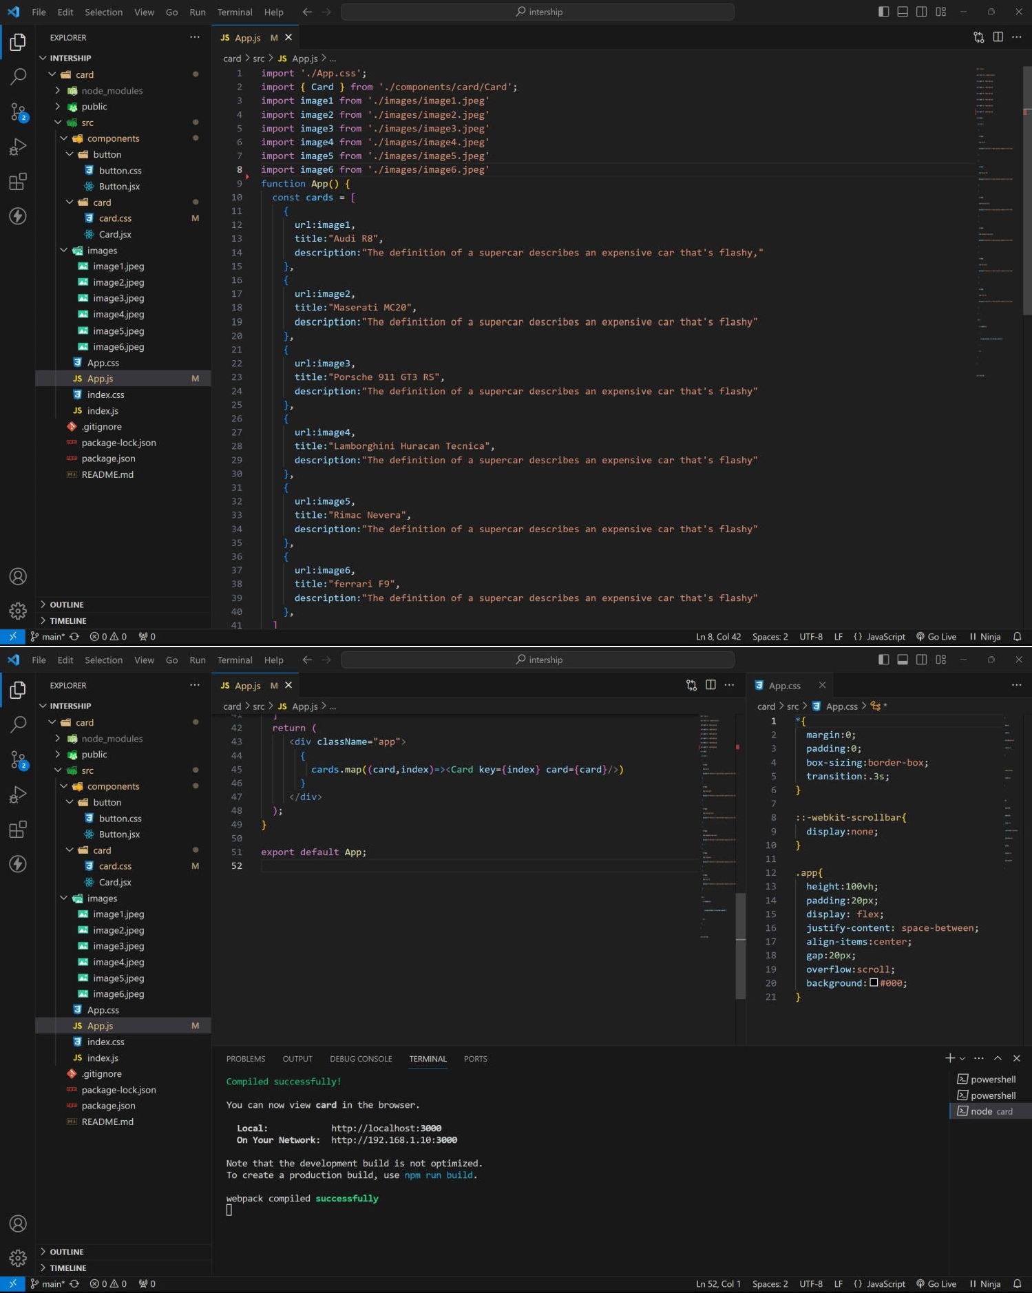

approach:

1. initially taking an array of objects like below

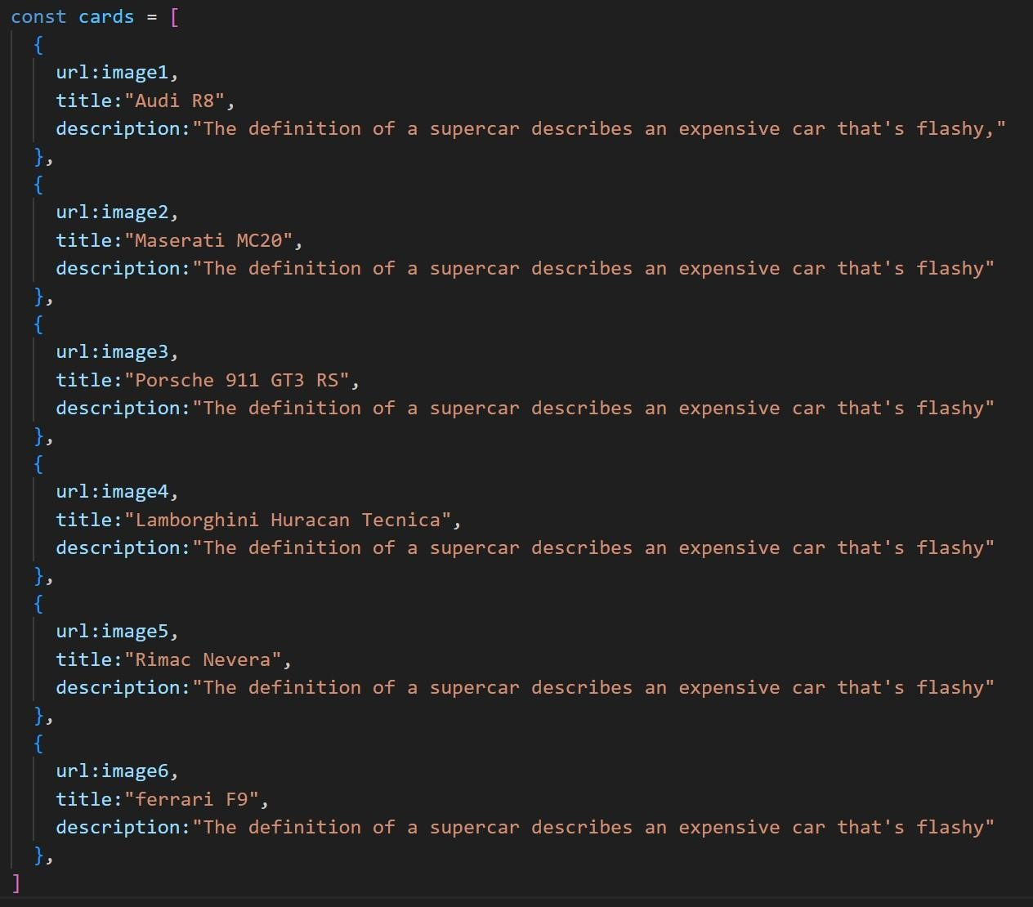

1. **. Passing this card array to child (card component) of App component by using props.**
2. **. getting data as argument like {card} in card component.**
3. **. in card component i use one state [show, set Show] to get extra info as description.**
4. **. When we click the button then show becomes true by assigning set Show (! show).**

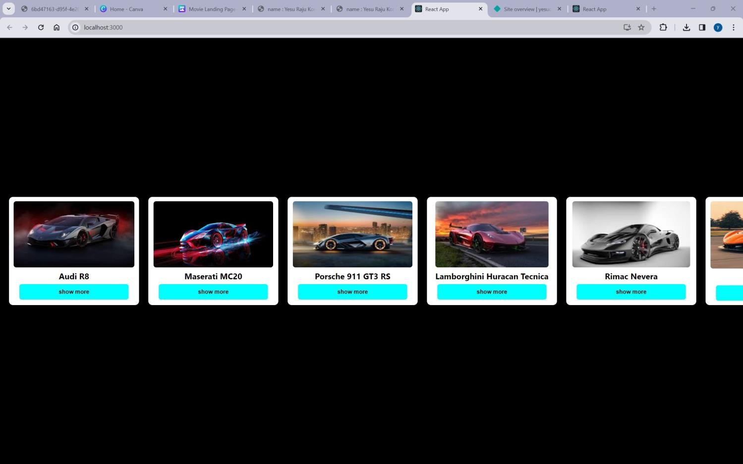OUTPUT:

AFTER BUTTON CLICKS :

